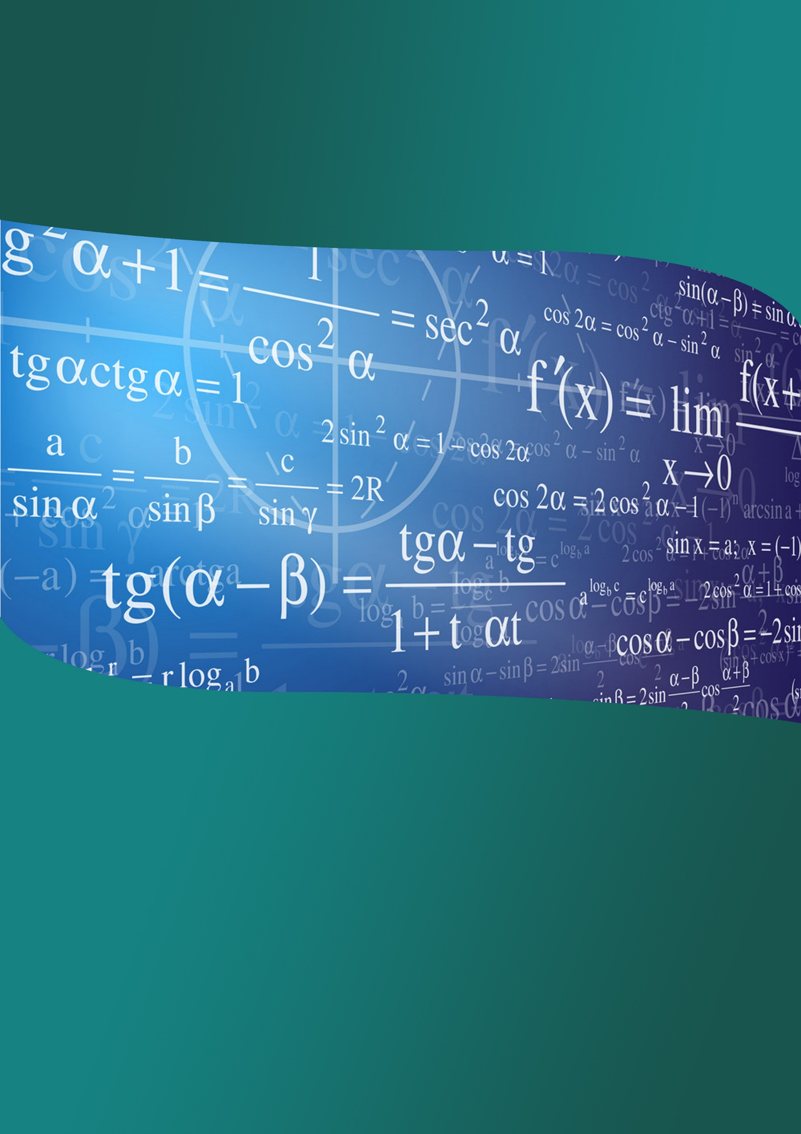
Indian Institute of Technology Guwahati

Teacher’s Enrichment Course in Undergraduate Mathematics Curriculum

July 01 -13, 2019

Conducted by:
Department of Mathematics, IIT Guwahati

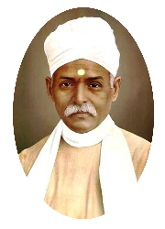
Organized by:
Center of Excellence in Science and Mathematics Education, under
Pandit Madan Mohan Malaviya National Mission on Teachers and Teaching
URL: http://www.iitg.ac.in/cet/pmmmnmtt.html

Announcement
Teacher’s Enrichment Course in Undergraduate Mathematics Curriculum
The Center of Excellence in Science and Mathematics Education, under Pandit Madan Mohan Malaviya National Mission on Teachers and Teaching, IIT Guwahati is organizing a two-week programme titled Teacher’s Enrichment Course in Undergraduate Mathematics Curriculum during July 01 – 13, 2019.
This workshop will be devoted to courses on Real Analysis, Linear Algebra, Modern Algebra and Differential Equations. Each course will consist of lectures as well as practical sessions and will cover important topics which are taught undergraduate honours course in Mathematics.
College and university teachers engaged in teaching of undergraduate Mathematics programs can apply for the Course. Those teachers who attended the TEC Programme held during 7 – 12 January, 2019 will be given preference.
Local hospitality including accommodation, food, etc. be provided and travel by 2nd AC train or by bus will be reimbursed to all outstation participants attending the course.
How to apply?
Interested persons are requested to apply by sending the duly signed completed application form (attached) to the following address:
Head, Department of Mathematics
IIT Guwahati, Guwahati 781039
Assam
Scanned copy of the application form can also be sent to the email to pmmmnmtt.iitg@gmail.com with a copy to mathoff@iitg.ac.in

Important Date:
Last date for applying for participation: 15 June, 2019.

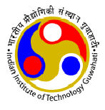
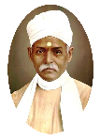
Teacher’s Enrichment Course in Undergraduate Mathematics Curriculum
01 – 13 July, 2019
Center for Excellence in Science & Mathematics Education, PMMMNMTT
Indian Institute of Technology Guwahati
Application Form
1. Name of the Teacher : ________________________________________________
2. Affiliation (Name of College/University) : ________________________________________________
3. Position held (Asst./Assoc Prof.) : ________________________________________________
4. Highest Degree (MSc/M.Phil./PhD) : ________________________________________________
5. Experience of teaching (in years)
Undergraduate : ________________________________________________
Postgraduate : ________________________________________________
6. Contact Address : ________________________________________________
________________________________________________
________________________________________________
7. Phone No.: __________________Email:_________________________________________________
_____________________________________
Signature of the Applicant
____________________________________
Date: ________________ Signature of the Principal (with seal)
Important Notes:
- All the information regarding this workshop including the Program details are available at:
http://www.iitg.ac.in/cet/pmmmnmtt.html
While visiting this link, please click on “Upcoming Activities" and then on
“Teacher’s Enrichment Course in Undergraduate Mathematics Curriculum: 01 - 13 July 2019”
(b) There is no registration fee.
(c) Accommodation and food will be provided. Travel by train in AC 2tier/equivalent or by Govt. Bus will be reimbursed.
(d) Last date for applying online: 15 June, 2019.
(e) Email id for sending the duly filled Application Form: pmmmnmtt.iitg@gmail.com with a copy to mathoff@iitg.ac.in

